**Atlas Odyssey – GK Mastermind**

**Main Starting Page (Rotating Sphere Rendered using OpenGl)**

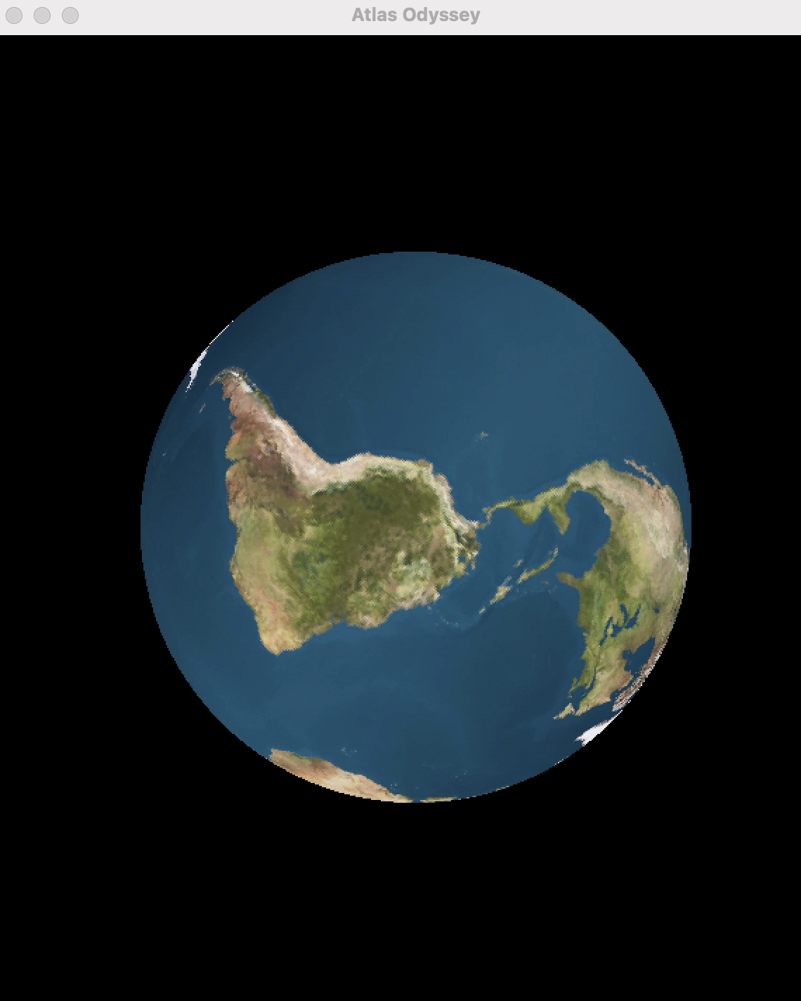

**Home Screen**

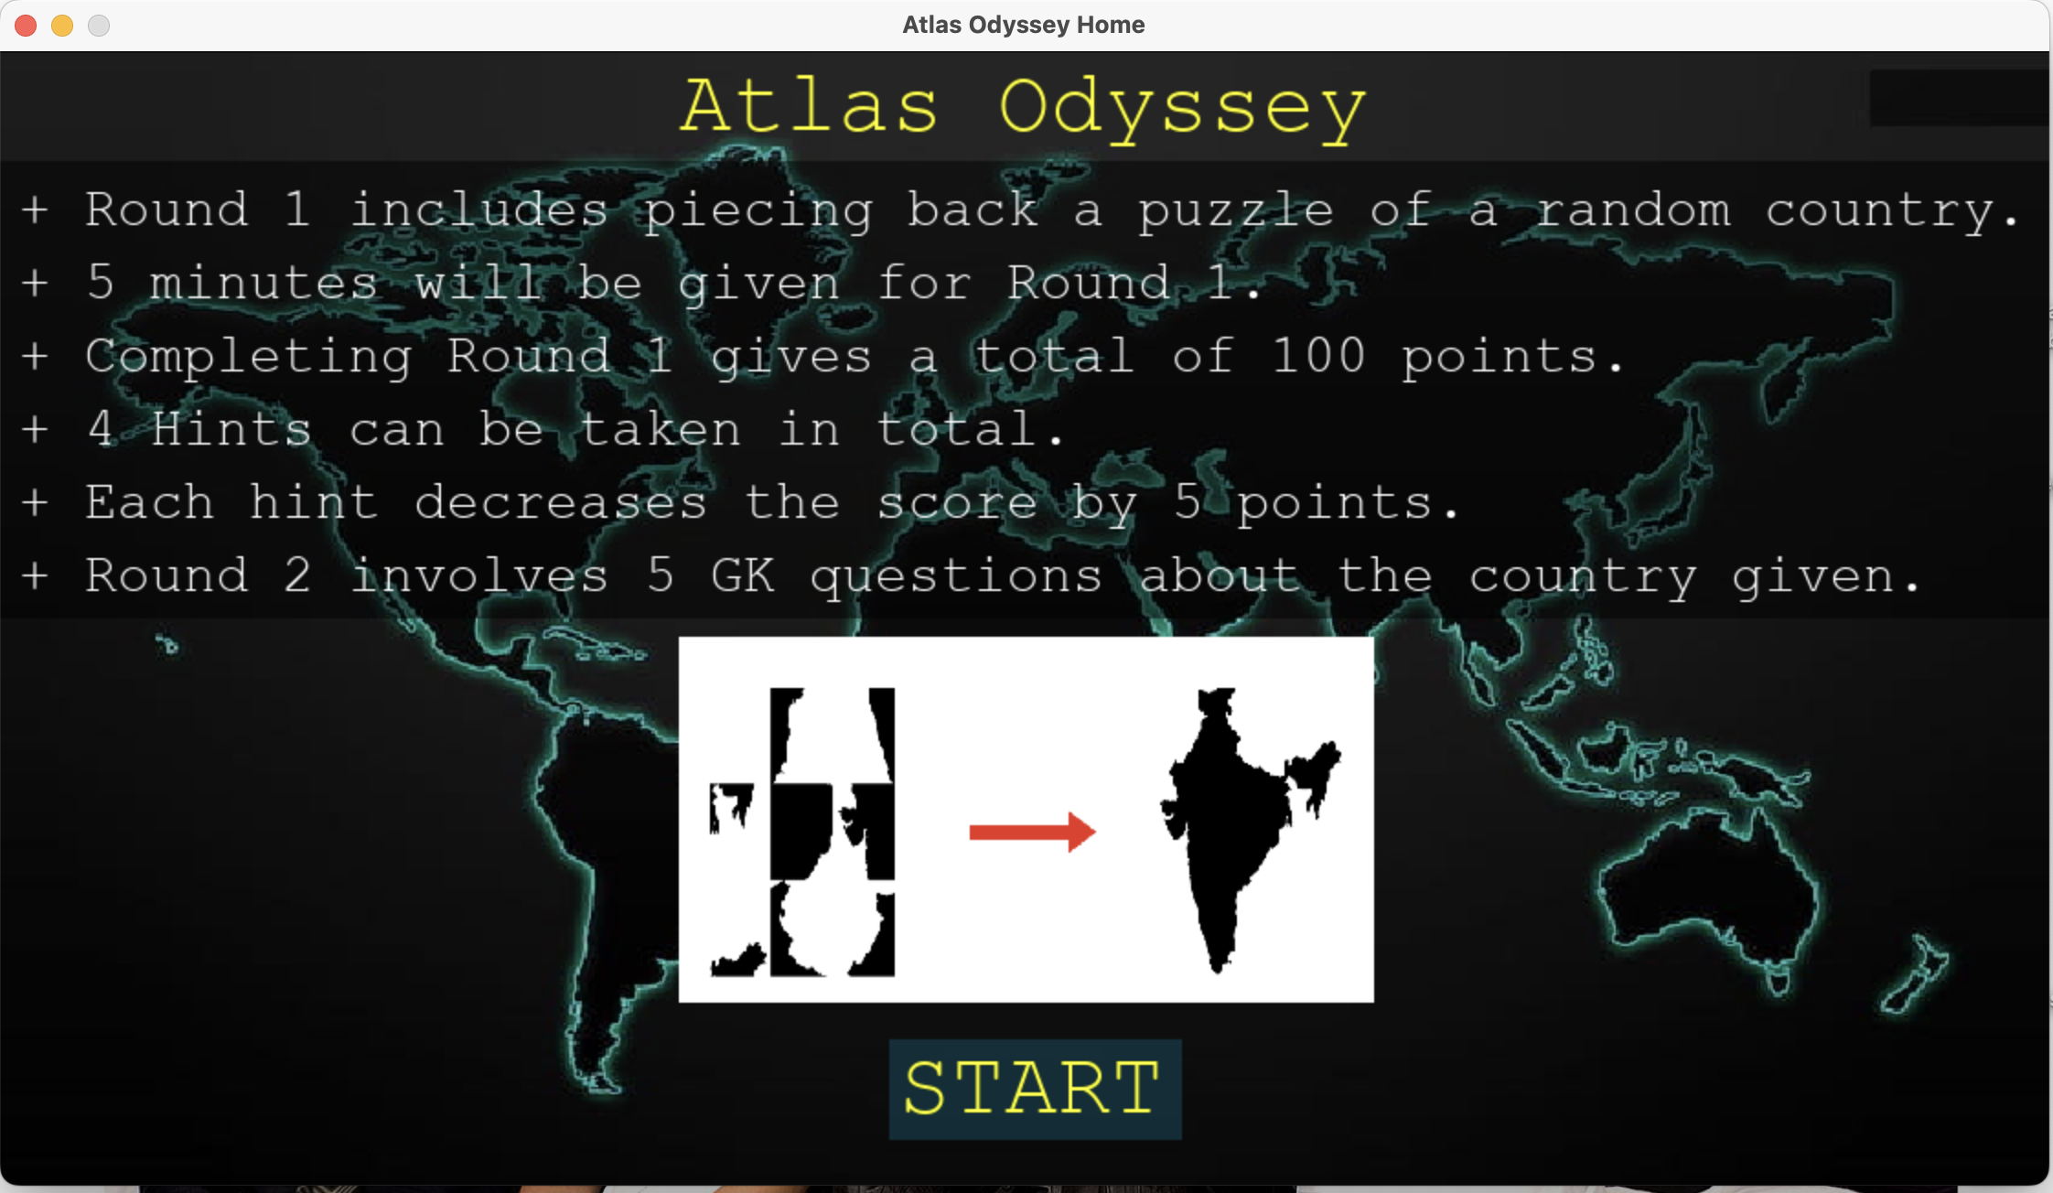

**Round 1 (Puzzle) : Random Country Rendered out of 194 possible countries**

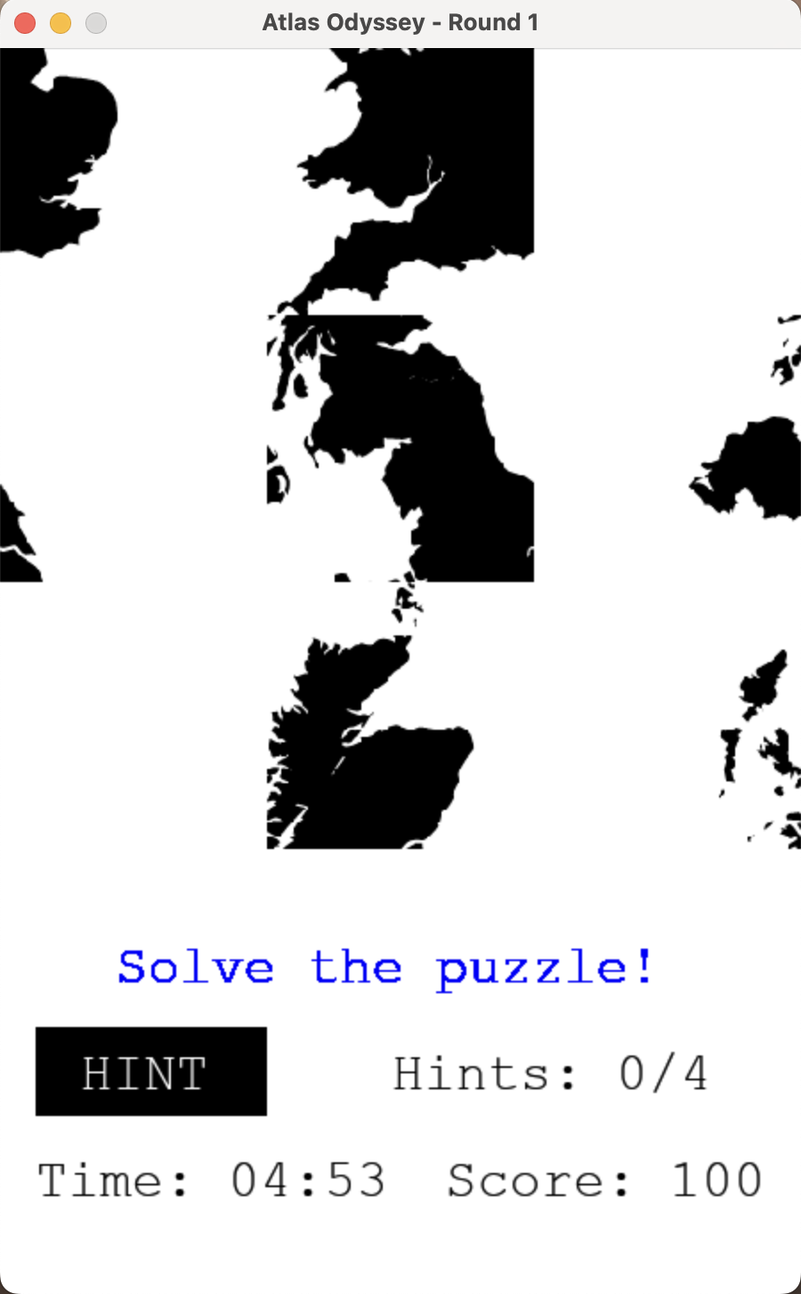

**Hint 1**

**Hint 2**

**Hint Counter Updating, and score decreasing**

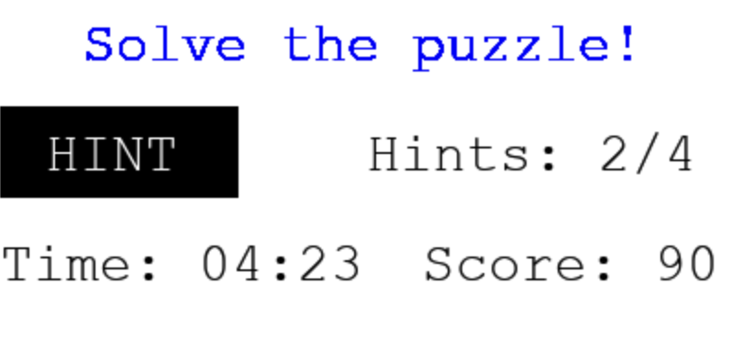

**Hint 3**

**Hint 4**

**Round 2: GK Quiz (Q1)**

**Round 2: GK Quiz (Q2)**

**Round 2: GK Quiz (Q3)**

**Round 2: GK Quiz (Q4)**

**Round 2: GK Quiz (Q5)**

**Round 2: GK Quiz Final Score**

**BACKEND**

**Merged Multiple datasets for getting data of 234 countries**

